Time for Walk Kansas!

Gather your team-mates – it’s time for Walk Kansas! K-State Research and Extension (KSRE) has been offering this health initiative since 2001. Online registration is available February 19 through March 15, and information about Walk Kansas and healthful living is available at www.walkkansas.org.

Here is a step-by-step guide that covers options for registering your team followed by general program information.

Register online:
▪ Before you go to register, recruit team members (at least 4 – you can add more later). You will need their email address, or mailing address if they do not have email. Program apparel (t-shirts, baseball tee, sweatshirts, etc) can be ordered when you register your team or later through the online store. You will be asked to pay the program fee ($8/person) for your team (plus any shirts you order at this time) at the end of registration, so be prepared to pay with credit card (PayPal) or follow up by sending a check. Talk to your team and select a goal for how many minutes of exercise each person will commit to per week – 2 ½ hours, 4 hours or 6 hours.
▪ When you are ready, go to www.walkkansasonline.org and follow these steps. If you reach a point during the process where you don’t have the needed information, click CANCEL and start again later. (Please do not exit out of the system without selecting CANCEL.)
- Click the yellow “Register” button
- Ready to Go! (Notice the link that will help you locate all KSRE offices in Kansas.)
- Select the county or district where you will participate
- Pick your Challenge. You have 3 options based on the goals your team goals: “8 Wonders Walk” = 2 ½ hrs/wk; “Cross Country” = 4 hrs/wk; “Little Balkans to Nicodemus” – 6 hr/wk
- Choose “Captain” if you are registering a team. Choose “Individual” if you do not have a team and would like to be placed on one.
- Enter the name of your team. (You can change the name later.)
- Create your personal user account. Select a username and password; then complete the required personal information.
- Now you are ready to build your team. Complete the required information for at least 4 people. Then confirm your team.

Important dates:

February 19 – Registration opens online

March 15 – Registration closes

March 17 – Go! Log exercise minutes and cups of fruits/vegetables

April 1 – Last day to order Walk Kansas apparel

May 4 – Walk Kansas 5K for the Fight! In Manhattan on the K-State campus

May 10 – Photo Challenge entries due

May 11 – Walk Kansas ends. Plan to attend the Walk Kansas Celebration event!
Kansas State University Agricultural Experiment Station and Cooperative Extension Service
K-State Research and Extension is an equal opportunity provider and employer.
Guide for Captains 2019 March 17 – May 11
10) Complete the next page by giving your consent to participate. You must consent and choose from the authorization statements to continue. Note: Each team mate that you entered will receive a message asking them to create a user profile and consent, just like you completed. Each person must do this before your team is ready to go.
11) Order summary -- pay online or select “Pay with Check.”
12) Congratulations – you are registered for Walk Kansas! Please note the name(s) of your local Extension Agent(s) and/or program coordinators if you have further questions.

Register with paper forms:
▪ Distribute participant information to each team member.
▪ Select a team challenge and complete the Team Registration Form (available from your local Extension Office.)
▪ Collect registration forms, program fees, and payment for t-shirts (optional). Return forms and payment (one check per team) to the Extension Office before March 15. Registration is not complete until all forms are collected and fees are paid.
Ready to go!
Reporting/logging online:
Once your team is “ready” (everyone has added user information, consented and all fees are paid) you will see a screen like this when you log in. New this year: The “team chat” features have been expanded so you will see when someone posts in the chat box, and you can log for team members from your Dashboard. (See these features below the purple bar.) Also, it is super easy to upload a photo/image to your team chat. Look for image icon in the chat box.

You will record your personal exercise minutes, fruits/veg here and you can also view how others on your team are doing by clicking on “My Team.” Check for “Events” in your area and “Resources” located on the top bar.
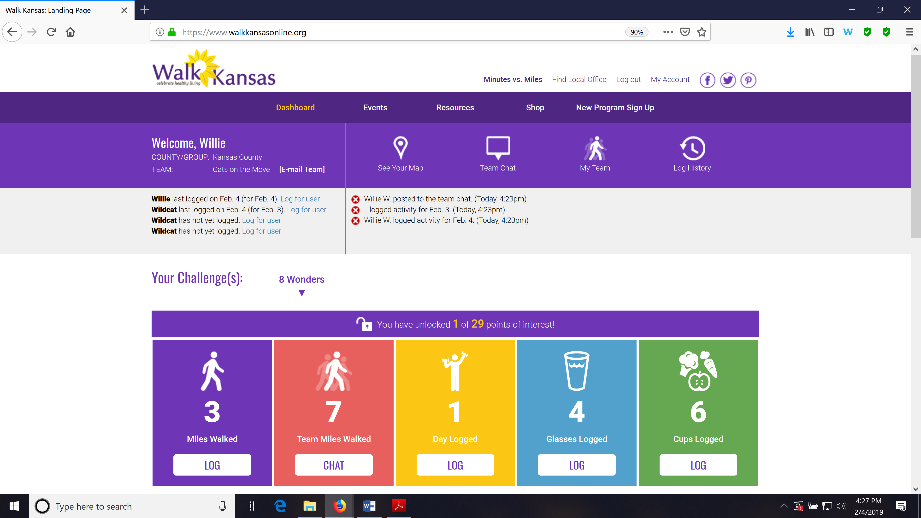

Make sure you and your team-mates check your progress on the map – click “See Your Map” on the large purple bar. As your team moves along the trail you will unlock points of interest. Some will have photos and all have a description of the town/community, area of interest, or Wonders of Kansas. You can go back and click on any dot you have passed through to read the information. Enjoy!! This year, captains will also have the option to switch your team to a different trail/challenge if you reach the end of your trail before Walk Kansas is over. Captains will receive a prompt and are the only ones that can move the team to another trail. The miles your team was gone will continue with you to the new trail OR you can select another option for your team to keep going.

Scroll down a bit further and you will see a “Leaderboard” at the bottom. You can view how other teams in your county/district are doing and at the very bottom you will see recent posts from “Kansas State University Walk Kansas” on Facebook. Be sure to like this page to see more.

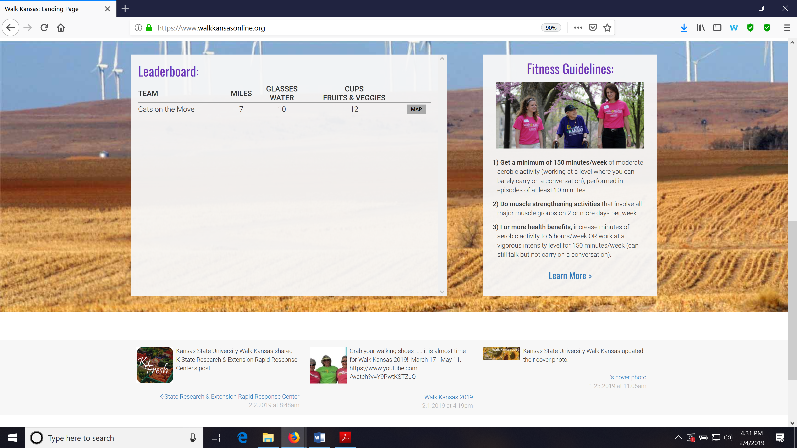
You can also view how teams in any county/district across the state are doing through the blue “Leaderboard” button on the login page.
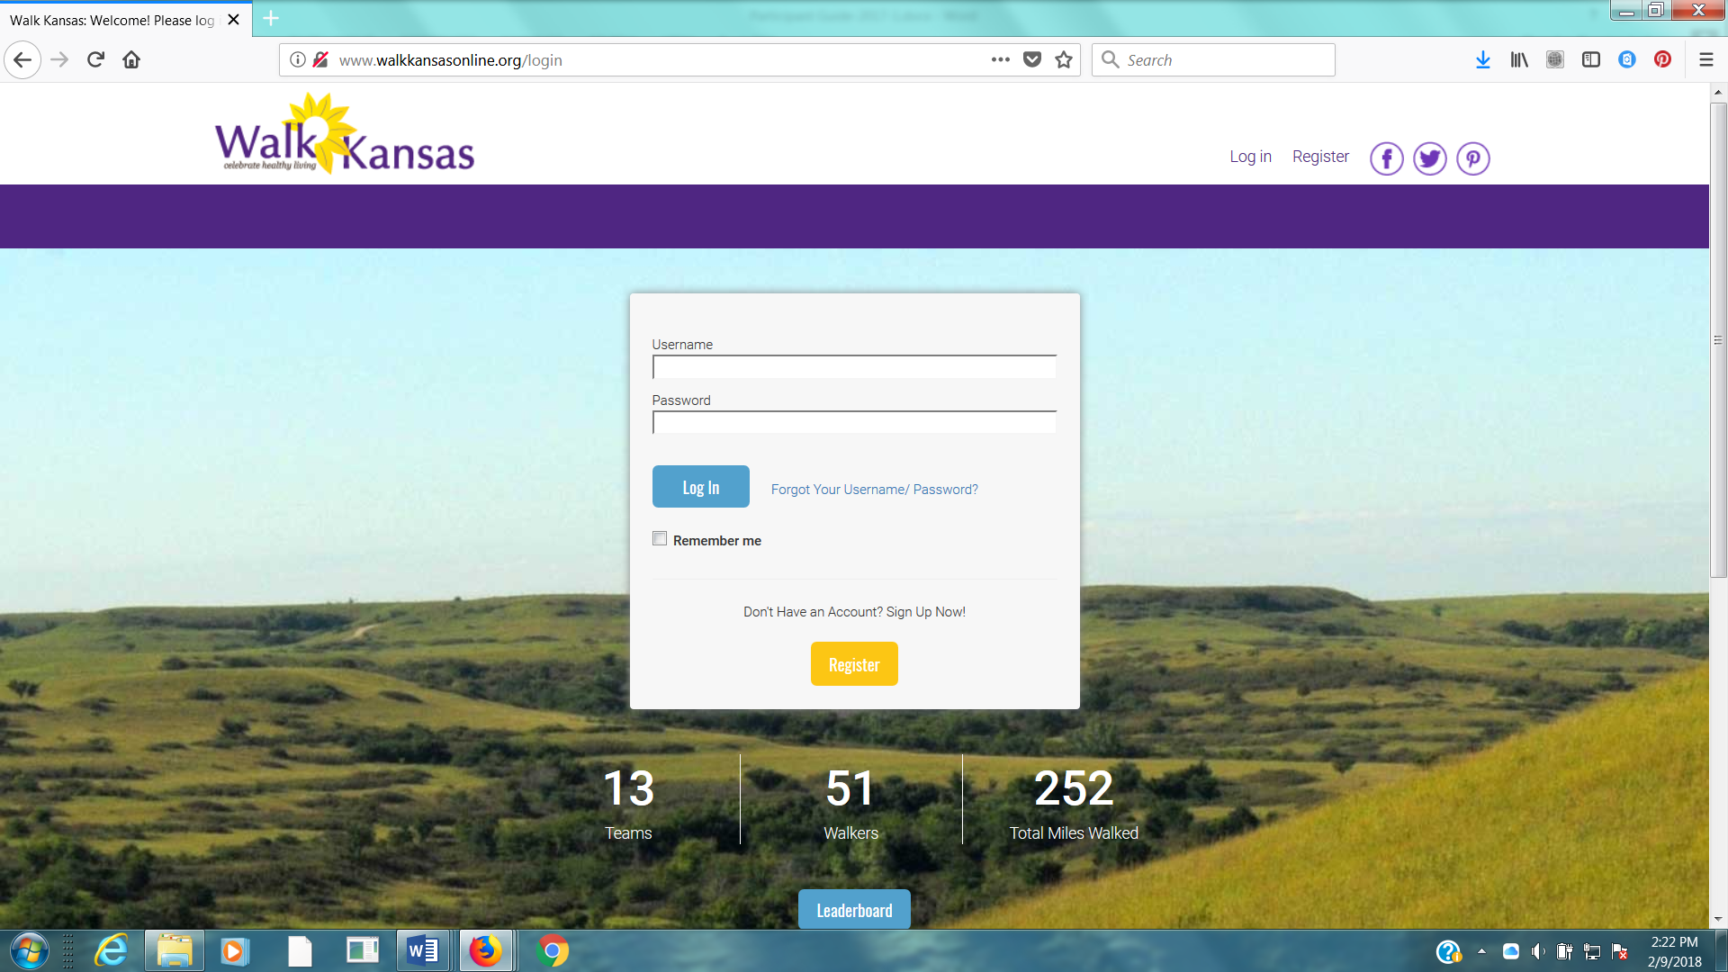

Reporting if logging by paper:
If team mates log on paper and report to you weekly, add totals once a week for that person by clicking on their name just below the purple bar on the left side. If you want to report only one number (total minutes of activity) for your entire team, report it as minutes for you – the captain – only.

Reminders for captains:
► Communicate with your team mates each week (email, chat in Walk KS system, phone call or in person.) All Walk Kansas participants will receive a message on Wednesday of each week that includes a short report of how their team is doing. Everyone will also receive a weekly newsletter.
► Make sure team-mates are receiving a weekly Walk Kansas newsletter. If not, report this to your local office. (Newsletters will also be posted in the “Resources” section. Top dark purple bar)
► Stay informed of events and activities offered in your community and participate when you can!
► Plan a fun activity(s) your team can do together during the 8 weeks of Walk Kansas.
► Encourage team mates to enter the photo contest – that includes you!

How to order t-shirts and more:
It is easy to order t-shirts and other apparel. Sign in to your account and click the “Shop” button on the purple bar at the top of the screen. This will take you to the online store for your county/district. Just shop from here and it will be added to your account. (Tax is charged on anything that ordered through the store.) Other team members can do the same once they have created a username/password. The online “shop” will close after the first 2 weeks of Walk Kansas, so place your orders early.

Captains also participate:
Not only are you the captain of your team, you are a Walk Kansas participant! Make sure you read through the participant materials, especially the Activity Guide. There is information here about pre/post fitness tests that your team may want to do and this is an activity you could do together. These are optional and can be very helpful and motivating. Make sure you also review what counts as Walk Kansas minutes as there are a few changes from previous years.

One last thing …. While Walk Kansas is sometimes viewed as a (friendly) competition, reaching the goal your team has selected is the most important. We want the physical activity and healthy eating habits you are your team mates practice, during the program, to continue. Keep it realistic, keep it fun and don’t worry about what others are doing or reporting. Be honest, be supportive to others and have a great Walk Kansas!!

