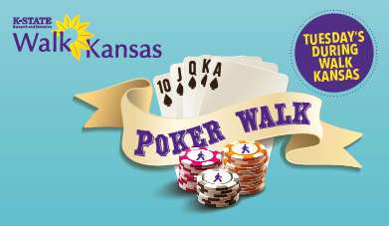
How it Works
- Get your first two cards at the sign-in table and start walking!
  - Walk a lap around the entire parking lot for one additional card
-OR-
  - Walk a lap around the entire block (around BES) for two cards
- Gather cards for each lap you walk
  - You may only have up to seven cards in your hand at once! (Once you have seven, you can keep walking and earning cards, but have to discard down to seven after each lap)
- Fill out the sign-in sheet
- Put your name on a Grand Prize ticket and put it in the bucket for the prize of your choice!

The top three poker hands each week will win a prize!

